SCCM – OSD Menu (HTA)

Dustin Estes  
24 February 2014

**Contents**

1 UI Overview 3

2 Task Sequence Integration 4

2.1 Create a Package for the OSD Menu 4

2.2 Add the Menu to the Task Sequence 4

2.3 Configure Conditions for the Dependent TS Steps 4

3 Version Control 6

4 References 7

# UI Overview

The install tab looks like the below screen shot.

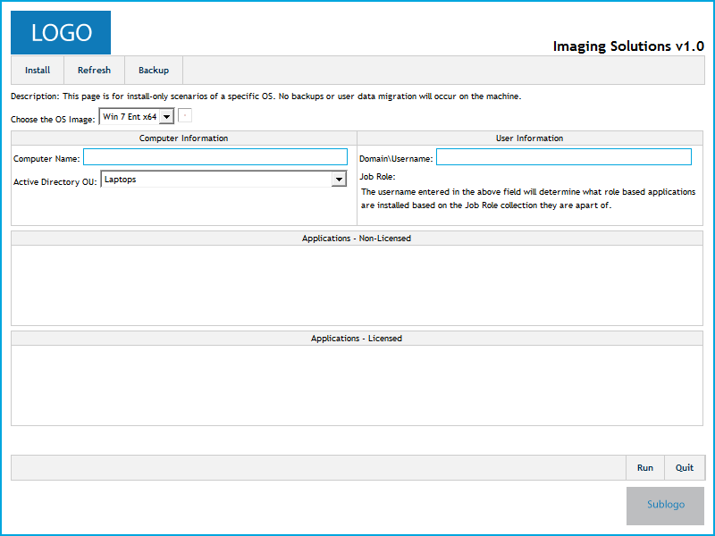

The following components can be found on the screen:

* **Choose the OS Image** – dropdown that can allow for multiple versions of an OS to be presented in a single deployment.
* **Computer Name** – this field allows you to input a computer name prior to imaging the machine. The field is character limited to 15 characters to prevent people from inputting a name that is too long.
* **Active Directory OU** – dropdown that allows predefined OUs to be presented
* **Domain\Username** – future integration for UDA assignment during deployment
* **Applications – Non-Licensed** – area for placing tickbox choices for installing optional software during OSD
* **Applications – Licensed** – are for placing tickbox choices for installing optional software during OSD

# Task Sequence Integration

Here is an example scenario for integrating the OSD Menu into a task sequence.

## Create a Package for the OSD Menu

Follow these steps for creating a package for the OSD Menu

1. Download the OSD Menu from TechNet
2. Extract the ZIP file to your SCCM source structure
3. Right click Packages in the SCCM Console
4. Click Create Package
5. Enter the following data on the Package page

* Name: OSD Menu
* Description: Optional
* Manufacturer: Dustin Estes
* Language: English
* Version: 2.2
* Check the box for “This package contains source files” and locate the folder

1. Enter the following data on the Program Type page

* Do not create a program

1. Click Finish

## Add the Menu to the Task Sequence

The below steps will help you add the menu to your task sequence. This HTA needs to run early on in the task sequence so it can set all the necessary variables.

1. Right click your task sequence
2. Click edit
3. Add a “Run Command Line” step

I usually add it after the “Format and Partition Disk” step

1. Change the name to something easy

For example “OSD Menu HTA”

1. Add the following to the command line field

mshta.exe "OSD_v2.2.hta"

1. Check the Package check mark
2. Browse for the previously created package

## Configure Conditions for the Dependent TS Steps

In order to utilize the Task Sequence variables that are set by this menu, you have to configure conditions. The conditions will reference the variables and allow the sequence to run or not based on your desired experience.

**Choose the OS Image** var_OSPicker

1. Locate your Apply Operating System Image step for Windows 7 x64
2. Click Options tab
3. Click Add Condition
4. Click Task Sequence Variable
5. Type the following values into the fields

* **Variable:** var_OSPicker
* **Condition:** Equals
* **Value:** Win7EntSP1x64

1. Click OK

**Computer Name** OSDComputerName

This step utilizes the builtin variable from SCCM so you don’t have to configure any steps in your task sequence.

**Active Directory OU** var_ADOU

This step uses a number of Apply Network Settings steps in order to provide the ability to choose.

1. Locate your current Apply Network Settings step
2. Click Options
3. Click Add Condition
4. Click Task Sequence Variable

* **Variable:** var_ADOU
* **Condition:** Eguals
* **Value:** “laptops”

1. Click OK

If you want to have multiple OU options then create multiple steps and perform the above.

**Domain\Username** SMSTSUdaUsers

This step adds the user as the primary user of the device. The value must be in domain\username format and must exist in the SCCM database.

1. Click Add -> General -> Set Task Sequence Variable

You need to add this near the front so it can prep the TS Environment for UDA

1. Put the following data into the input fields

* **Name:** Enable UDA – Auto
* **Description:** <optional>
* **Task Sequence Variable:** SMSTSAssignUsersMode
* **Value:** Auto

1. Click Apply

This step turns the UDA mode to Auto. Inside of the HTA is a process to add the username you input into the builtin UDA Username variable so it can be configured in the database.

# Software Revisions

Keep track of software revisions and the changes within that revision in this section.

|  |  |  |  |
| --- | --- | --- | --- |
| **Rev. #** | **Rev. Date** | **Rev. Changes** | **Owner** |
| 2.3 | 02/24/2014 | The following changes were made:  **ComputerName = Serial Number of Device**   * Moved lines (39-43) to (50-54) to align with below addition * Added lines (47-49;55) to auto-populate the computername field * Modified line 474: Added **disabled=”true”** to the input box so that it will show the machine name but not allow modification to prevent accidental changes.   **VDI Workstations OU Option**   * Added lines (154-156) to allow the TS Variable to be set for the 5th option in the dropdown for VDI machines * Added line (487) to allow for the 5th option to show up in the drop down | Dustin Estes |
|  |  |  |  |

# Version Control

Keep track of changes to the document in this section.

|  |  |  |  |
| --- | --- | --- | --- |
| **Rev. #** | **Rev. Date** | **Rev. Notes** | **Owner** |
| 1 | 02/23/2014 | Document created | Dustin Estes |
| 2 | 02/24/2014 | Added “Software Revisions” section to track software version changes | Dustin Estes |

# References

**There are no sources in the current document.**